User guide

Sunday, July 29, 2018

8:32 PM

**Thanks for downloading the MoneyBMineWPF application.**

**How to install the app?**

It is a zip file, so please right-click on the file and '7-zip' it first;

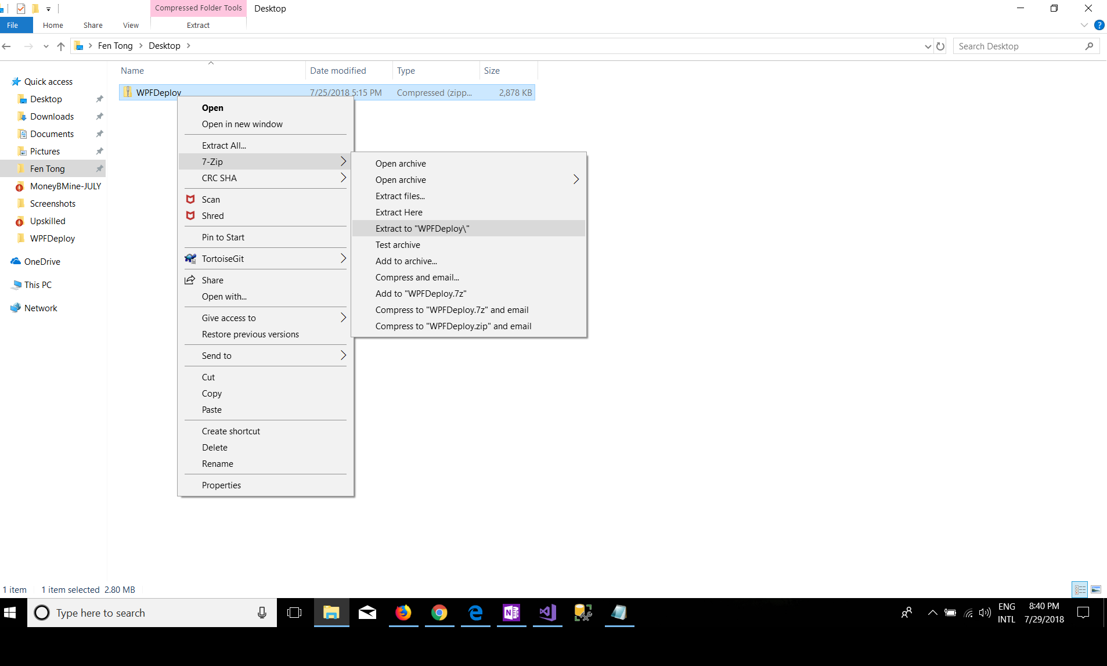

After extracting the downloaded file, you will see a list of files;

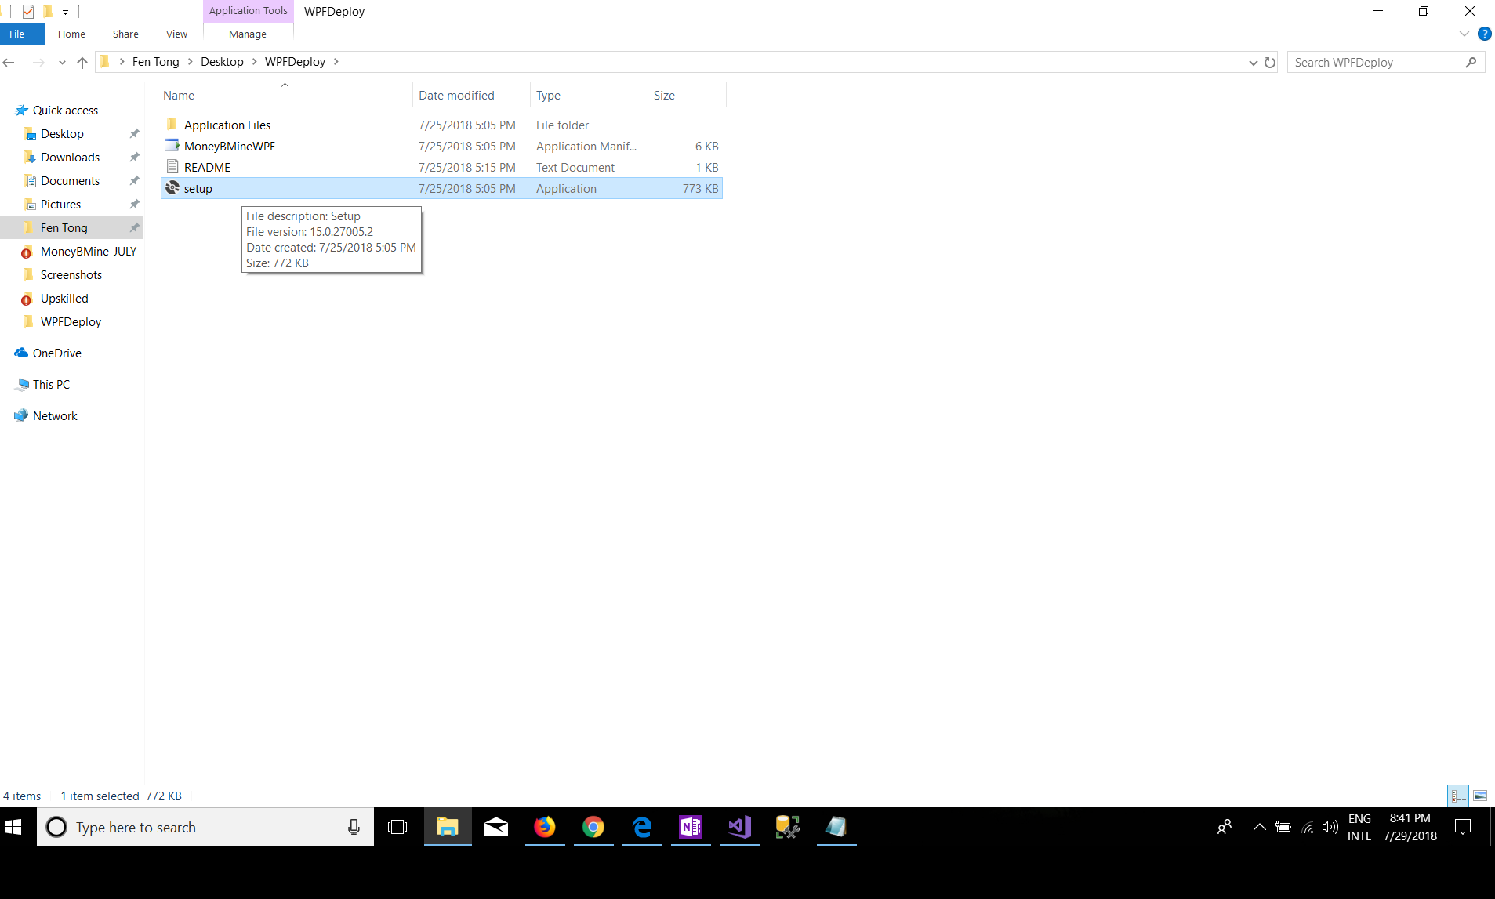

Then double-click the file 'setup.exe' to install the MoneyBMineWPF;

Click Install;

The MoneyBMineWPF app will run after the first installation;

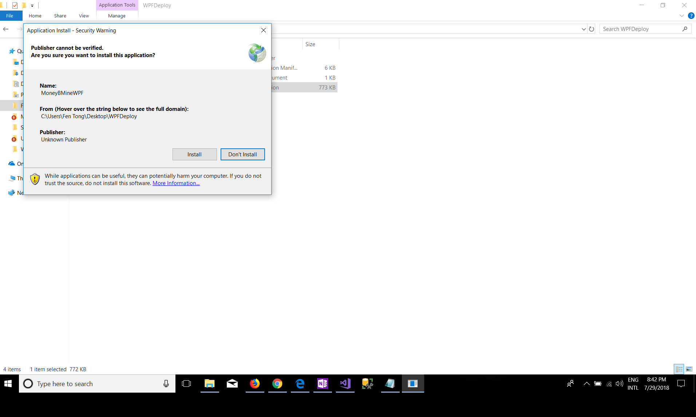

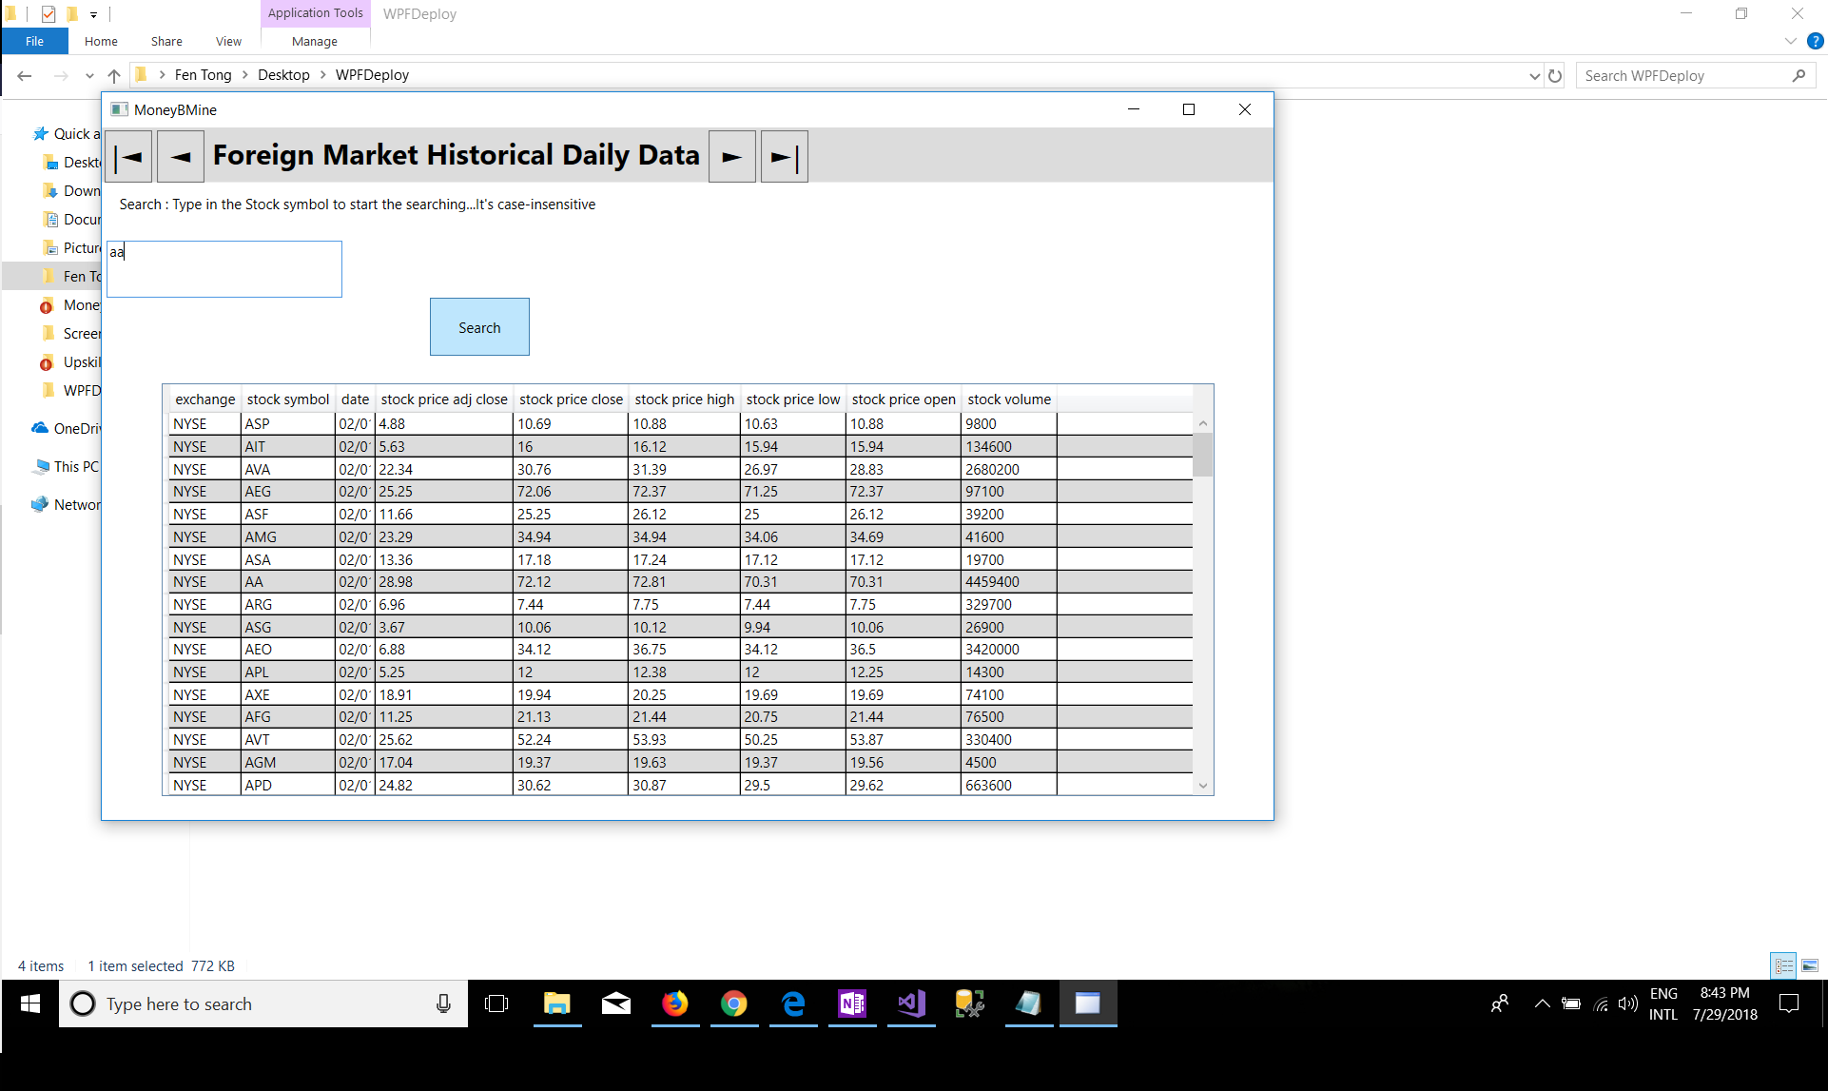

Now you can run the application from the file by double-click the 'setup.exe';

Or you can find the APP in your installed applications by clicking the start button on the left bottom of your desktop or laptop.

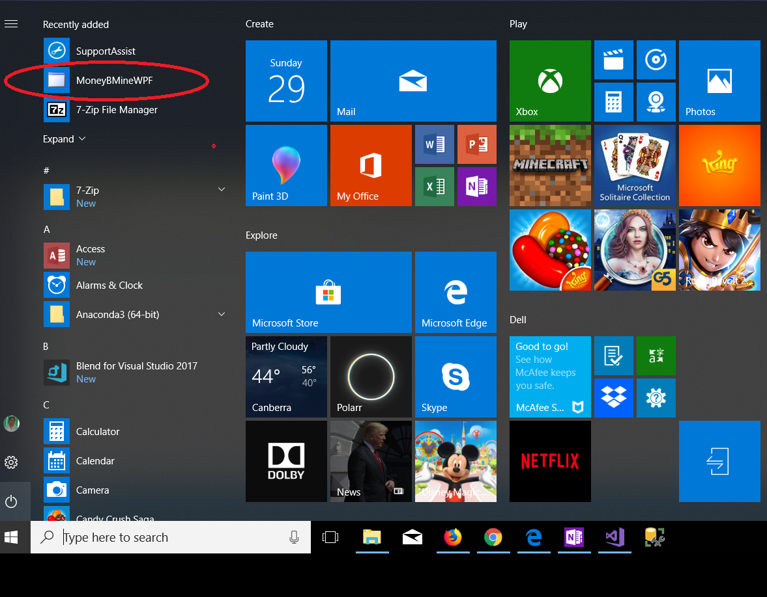

**The historical data now is on your computer safely. You can check the data anytime you want even no internet service.**

Every time you launch the application, it will check the update data automatically and update it.

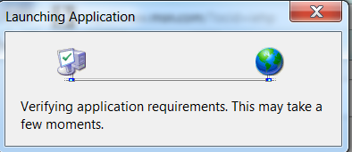

**How to search the data in MoneyBMineWPF?**

You can type in the stock symbol and press the Search button.

You also can sort the data by press the header of the column.



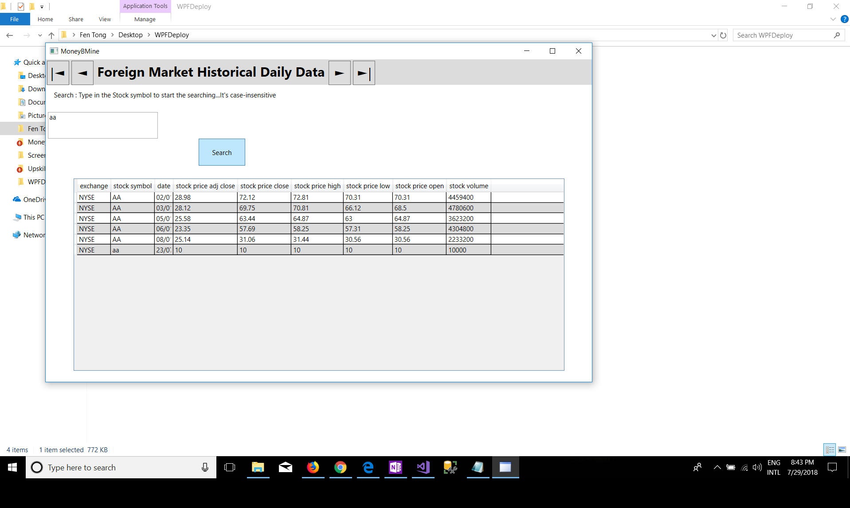

**How to uninstall the app?**

Find the APP in your installed applications by clicking the start button on the left bottom of your desktop or laptop;

Right-click on the app;

Click on the Uninstall;

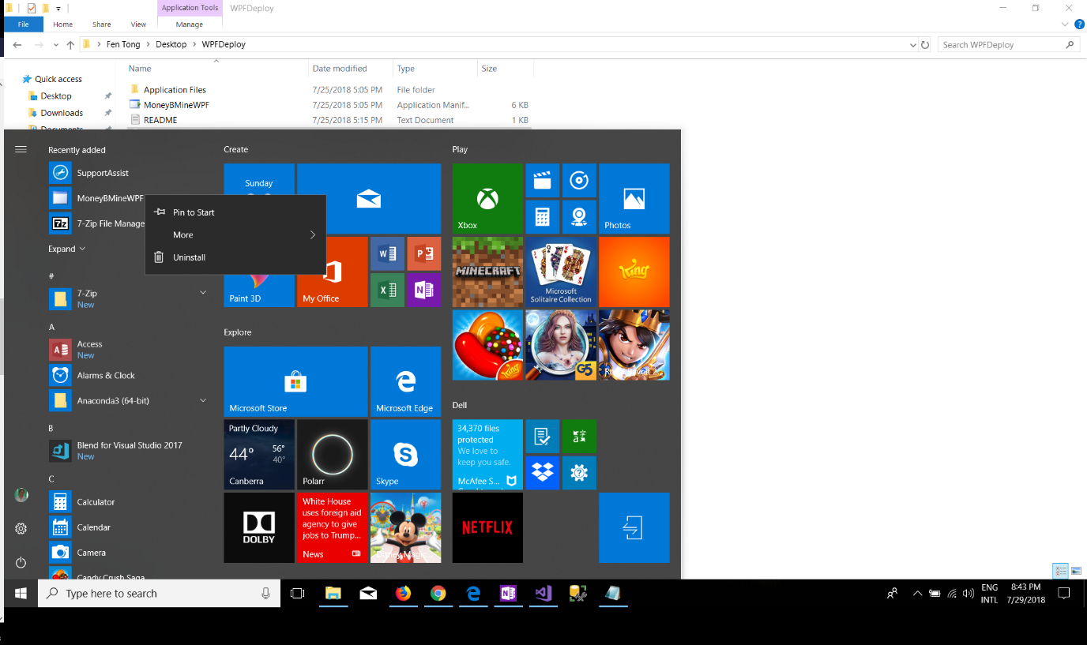

Find and click the MoneyBMineWPF app;

Then click Uninstall/change button as shown below;

Home Share View  JL Fen Tong  Name  * Quick access  Desktop  J' Downloads  Documents  Pictures  Fen Tong  O MoneyBMine-JULY  O Upskilled  WPFDeploy  oneDrive  This pc  Network  4 it ems I item selected 772 KB  o  Type here to search  Application Tools WPF Oy  Manag  Desktop WPFDep10y  Programs and Features  Control panel  Control Panel Home  View installed updates  Turn Windows features on or  o  0  search WPFDepIoy  Date modified  Type  programs programs and Features  Uninstall or change a program  To uninstall a program, select it from the list and then click Uninstall, Change, or Repair.  Organize •  Name  Uninstall/Change  t4Microsoft Visual Studio Installer  Microsoft Visual Studio Tools for Applications 2015  Microsoft Visual Studio Tools for Applications 2015  Microsoft VSS Writer for SQL Server 2017  Microsoft Web Deploy 40  Mozilla Firefox 610.1 (x64 en-US)  Mozilla Maintenance Service  O python 364 (Anaconda3 5.1.0 64-bit)  python 3.6.5 (64-bit)  python Launcher  Qualcomm I Iac Wireless LAN&BIuetOOth Installer  QuickSet64  Realtek Card Reader  Realtek High Definition Audio Driver  S) SmartByte Drivers and Services  *'TortoiseGit 2.600 (64 bit)  MoneyBMineWPF product version:  Help link  Publisher  Microsoft Corporation  Microsoft Corporation  Microsoft Corporation  Microsoft Corporation  Microsoft Corporation  Mozilla  Mozilla  Anaconda, Inc.  Python Software Foundation  Python Software Foundation  Qualcomm  Dell Inc.  Realtek Semiconductor Corp.  Realtek Semiconductor Corp.  Rivet Networks  TortoiseGit  Installed On  7/18/2018  7/18/2018  7/18/2018  7/19/2018  7/18/2018  7/19/2018  7/19/2018  7/18/2018  7/18/2018  7/18/2018  6/29/2018  6/29/2018  6/30/2018  6/29/2018  7/25/2018  7/20/2018  Size  8.72  52.1 MB  317 MB  13B MB  144 MB  278 KB  149 MB  1.75  20.5 MB  146 M 3  228 MB  22.3 MB  418 MB  Search Programs and Features  Version  1.1&1251.625  14.023829  140.2310720  1401000.169  10.0.1992  100.1  61.01  61.01  5.10  3.651500  3.662950  1100.10454  11.140  10014393.31228  60.18403  12.600  2.600  I.o.o.l  fi  Update information:  ENG  INTL  8:43 PM  7/29/2018 

Click OK to uninstall the app.

Home  Share  View  Application Tools WPFDepIoy  Manage  Search WPFDeploy  o  p  Fen Tong > Desktop > WPFDeploy  Name  Date modified  x  Type  ograms and Features  Size  * Quick access  Desktop  MoneyBMineWPF Maintenance  Downloads  MoneyBMineWPF  Documents  Pictures  Fen Tong  O MoneyBMine-J  Screenshots  O Upskilled  WPFDeploy  OneDrive  This pc  Network  Choose the type of maintenance you need.  •C) Restore the application to its previous state.  @ Remove the application from this computer.  change a program  ram, select it from the list and then click Uninstall, Change, or Repair.  Search Programs and Features  Version  1.16.1251.625  140.23829  14.0.23107.20  14.0.1000.169  100.1992  I.o.o.l  610.1  610.1  5.10  3.6.5150.0  3.6.6295.0  11.0.0.10454  11.140  10.0.14393.31228  60.18403  1.2.600  2.6.o.o  p  O  all/Change  tudio Installer  OK  Cancel  More Information..  tudio Tools for Applications 2015  •croso •sua tudio Tools for Applications 2015 La.„  Microsoft VSS Writer for SQL Server 2017  Microsoft Web Deploy 4.0  MoneyBMineWPF  Mozilla Firefox 610.1 (x64 en US)  Mozilla Maintenance Service  O Python 36.4 (Anaconda3 5.10 64 bit)  Python 36.5 (64 bit)  Python Launcher  A  Qualcomm 1 lac Wireless LAN&Bluetooth Installer  ickSet64  Realtek Card Reader  Realtek High Definition Audio Driver  s  SmartByte Drivers and Services  *'TortoiseGit 2.6.0.0 (64 bit)  Publisher  Microsoft Corporation  Microsoft Corporation  Microsoft Corporation  Microsoft Corporation  Microsoft Corporation  MoneyBMineWPF  Mozilla  Mozilla  Anaconda, Inc.  Python Software Foundation  Python Software Foundation  Qualcomm  Dell Inc.  Realtek Semiconductor Corp.  Realtek Semiconductor Corp.  Rivet Networks  TortoiseGit  Installed On  7/18/2018  7/18/2018  7/18/2018  7/19/2018  7/18/2018  7/29/2018  7/19/2018  7/19/2018  7/18/2018  7/18/2018  7/18/2018  6/29/2018  6/29/2018  6/30/2018  6/29/2018  7/25/2018  7/20/2018  Size  8.72 MB  52.1 MB  3.17 MB  138 MB  144 MB  278 KB  149 MB  1.75 MB  20.5 MB  14.6 MB  228 MB  22.3 MB  41.5 MB  MoneyBMineWPF  Product version:  Help link  1.001  Update information:  4 items 1 item selected 772 KB  Type here to search  ENG  INTL  8.•43 PM  7/29/2018 